Posted 10/11/2011 at 8:38 am by JAV

Municipal Building Committee

Agenda
Fireplace Room, Old Library
Tuesday, October 18, 2011
7:30 AM

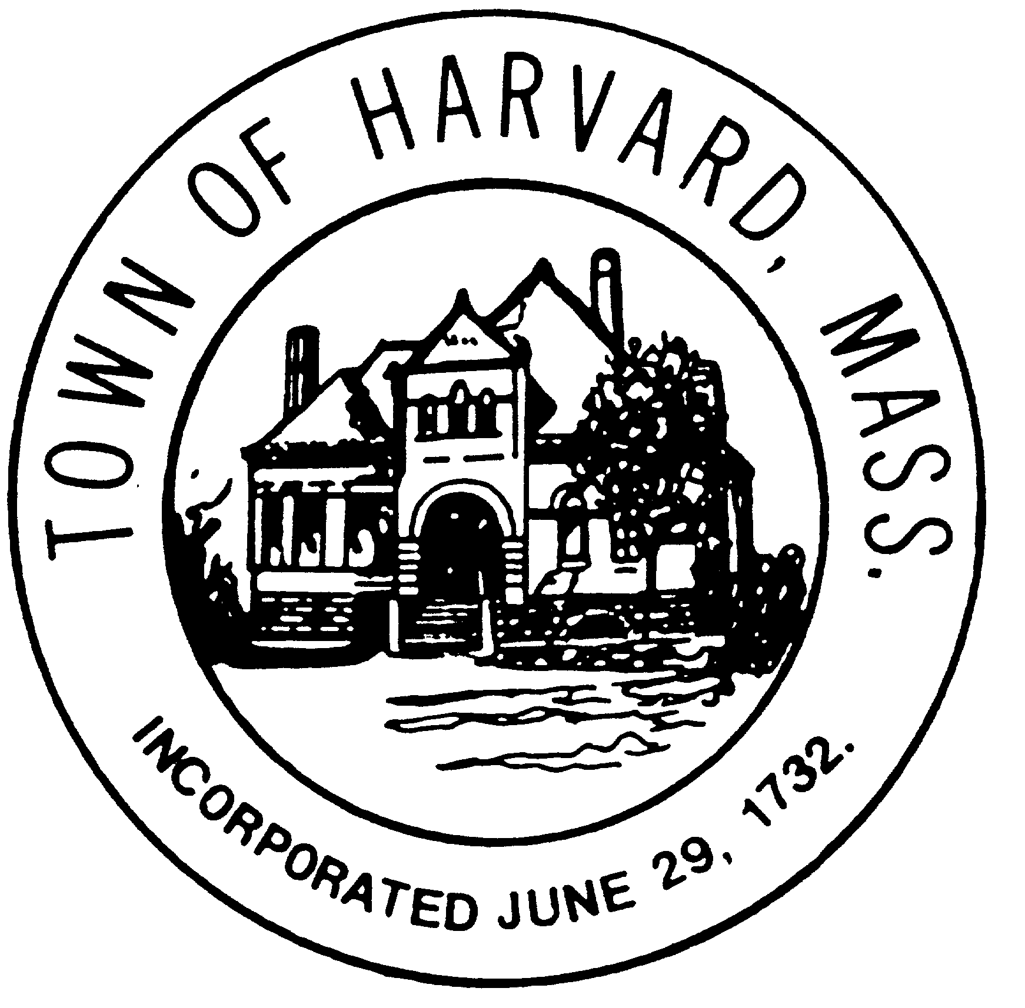
- Approve Minutes

- Designer procurement process
  - Update from DTI
  - Discussion of proposal review and short list process

- Agenda for next meeting

